Walmart Sales

**Group-8**

Aminaa Tserendagva

Cecilia Holmberg

Martina Paulraj

Omer Mohammed

Prayas Kundu

Yu-Ting Kuang

**Overview of the Dashboard**

The dashboard we developed using the Walmart Sales data provides several insights of aspects of the data. Using the given data, our research motivation is to identify the primary revenue-generating branches for Walmart and identify the predominant gender contributing significantly to the income within specific stores. The dashboard analyzes these aspects by looking at which one of the branches generates the most sales for Walmart. At the branch that generates the most sales, we investigated what types of customers generate the biggest profit, which gives Walmart a good indication of who their target audience is to increase their overall profit.

**Data Cleaning**

We utilized the Walmart Sales dataset for our project, employing data cleaning processes that involved formatting cells. To ensure uniformity, we applied appropriate functions, and we formatted the date column to display the year/month format through the Format Cells > Custom > Select Year/Month option.

**Schema:**

We utilized a schema with column headers matching the dataset and assigned appropriate data types, including string, float, and integer. Additionally, we provided relevant descriptions based on each column's title.

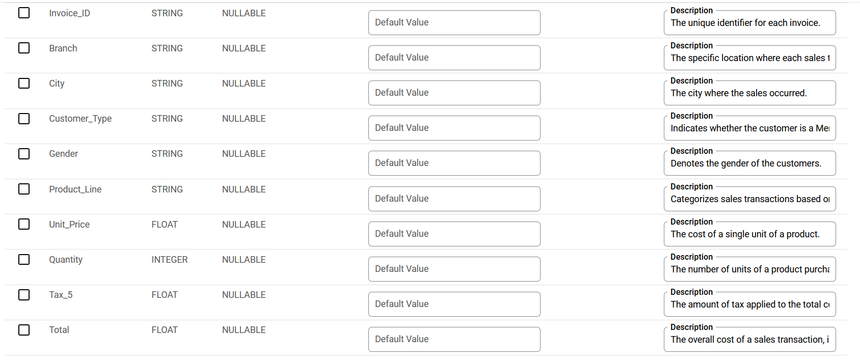

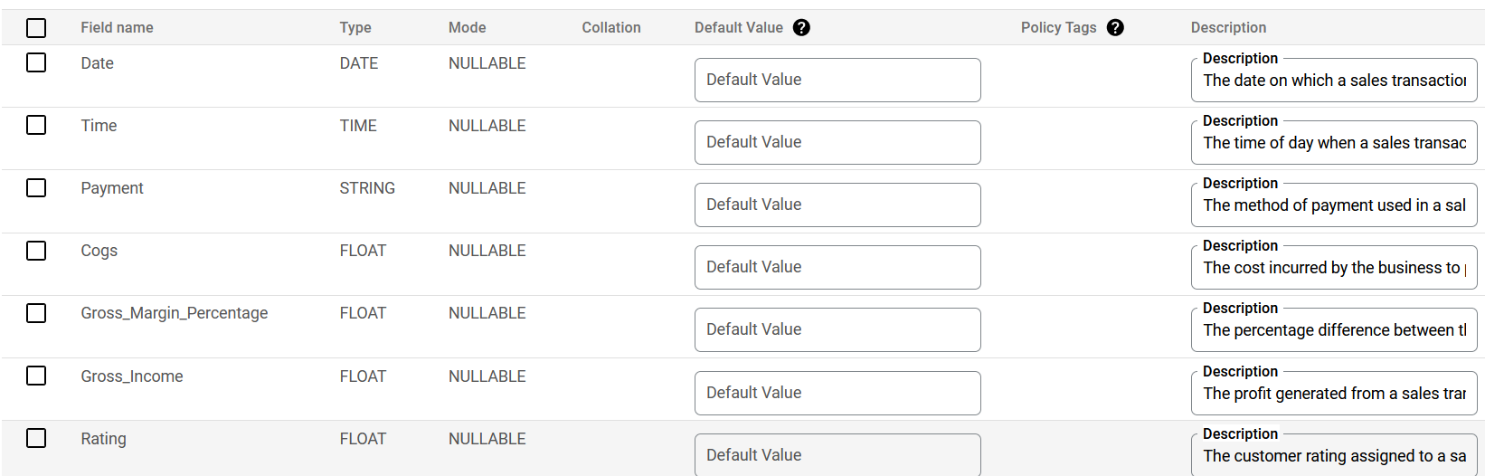

**Strategic Insights:**

The analysis of the Walmart Sales dataset aims to answer several general questions, covering different aspects of the business. Here's an outline of some of the key questions addressed by the analysis:

* **Sales Performance:**
  + Which branch is generating the highest sales for Walmart in Myanmar during the first quarter (Q1) of 2019?
* **Customer Demographics:**
  + What is the demographic composition of customers in Branch C, particularly focusing on gender distribution?
* **Product Preferences:**
  + What are the best-selling products in Branch C, and how do they contribute to overall sales trends?
* **Purchasing Behavior:**
  + How does the purchasing behavior of members compare to non-members?
* **Payment Methods and Trends:**
  + What are the current trends in payment methods, particularly focusing on cashback offers and credit card usage?
* **Customer Satisfaction and Ratings:**
  + How satisfied are customers with their shopping experiences in each branch, as indicated by average ratings?

**Overview of Dataset: Walmart Sales**

This panel provides an overview of the dataset, focusing on first quarter (Jan, Feb, Mar) month sales in three major stores located in Myanmar. The dataset includes demographic preferences influencing sales, customer ratings, transaction date and time, total quantity procured, as well as gross income, profit, tax, and gross margin associated with each purchase.

**Quarterly Total Sales by Branch**

This panel shows the first three months Q1 (2019/1-2019/3) of total amounts sold in each branch. As we can see, Branch A is in Yangon, and has the sales figure of 106K; Branch B is located in Naypyidaw Mandalay and has the sales figure of 106K; Branch C is located in and has the sales figure of 111K.

**Average Rating by Branch**

This panel shows the average rating received from customers in each branch, as we can see, Branch A had received average rating of 6.58 out of 10, Branch B had received average rating of 6.38 out of 10, Branch C had received average rating of 6.65 out of 10, the better the rating means the more satisfying of the customer had experience in the specific store.

**Spending Total by Gender: Branch C**

This panel chart presents the total cost spent by gender in Branch C. It highlights that the total cost spent by female customers in this branch is approximately $61.7k, which is more than the total cost spent by male customers in this branch, which is around $48.9k. This information can be interpreted as female customers spending more than male customers in Branch C.

**Female Customer Average Ratings in Branch C**

This panel represents the average ratings given by female customers to various categories of products or services offered in Branch C of a company. We can see that female customers have an average rating of 18% for fashion accessories, 16% for electronic accessories, sports, and travel. The average rating for food and beverages, health and beauty, and home and lifestyle is 17% for each category.

This panel provides an overview of the total quantity of purchases made by female customers in branch C, revealing patterns in their shopping preferences. The standout category is Food and Beverages, with a substantial quantity of 231, indicating that customers predominantly utilize Walmart for daily essentials, emphasizing the store's role in fulfilling basic needs. The second-highest quantity is observed in Fashion and Accessories at 192, underscoring a strong interest in fashion-related items among these shoppers. A noteworthy quantity of 190 in Sports and Travel suggests a keen interest in products related to sports and travel experiences.

Electronic Accessories, though slightly lower at 164, still signifies a significant interest in technology and electronic gadgets. Home and Lifestyle, with a quantity of 152, reflects a focus on items associated with home decor or improvement. Health and Beauty products, with a quantity of 120, indicate a certain level of interest in personal care, albeit at a comparatively lower level. The prominence of Food and Beverages as essential items for daily living may explain their higher quantity, reflecting a priority on immediate consumption and satisfaction.

**Female Payment Method in Branch C**

This panel emphasizes the current trend of cashback offers nowadays and loyalty programs associated with the credit card are huge. Also, the convenience and security of using credit cards could be appealing to a segment of customers. Some customers prefer the traditional approach of using cash, possibly due to a personal preference for physical currency or concerns about electronic transactions. Cash payments might also be influenced by the demographics of the customer base, as certain age groups or regions may have a stronger preference for cash transactions. And the balance between cash and e-Wallet payments may be a result of promotional campaigns or partnerships with specific e-Wallet providers, influencing customer choices.

**Female Member Status: Branch C**

The bar chart illustrates the distribution of female customers as members and regular customers in Branch C, with 40.1% being regular and 39.9% being members. This suggests an even distribution, indicating a good balance in the branch.

**Total Value of Gross Income by Female Customers in Branch C**

The panel shows the gross income, which is the total income before any deductions, such as tax deductions, and total value which is the sales price plus tax amount of 5%. This is a graph that indicates these two numbers, gross income, and total value, for female customers, who are the predominant customers who generate the most profit, in branch C which is the branch with the highest sales.

**Final Dashboard**

This dashboard enhances the overall performance of Branch C by analyzing total sales performance and customer ratings. We have further segmented the demographic that contributes many sales, examining their preferences such as liking and card preferences. This analysis aims to improve future sales strategies.

**Descriptive Summary**

The dashboard we developed using Walmart Sales data offers a comprehensive overview of various aspects related to sales performance, customer demographics, and product preferences in Branch C. Here's a summary of the key findings and recommendations for your consideration:

**Key Findings:**

* Sales Performance: Branch C stands out with the highest sales figure of $111K in the first quarter (Q1) of 2019. This branch's performance is crucial for Walmart's overall revenue in Myanmar.
* Customer Ratings: Customer satisfaction, as indicated by average ratings, is relatively high in Branch C, with an average rating of 6.65 out of 10. This suggests positive customer experiences in the store.
* Female Customer Preferences: Female customers in Branch C contribute significantly to sales, with a focus on essential items like Food and Beverages (quantity: 231) and Fashion and Accessories (quantity: 192). This demographic preference provides insights into potential target areas for marketing strategies.
* Payment Methods: The panel on payment methods suggests a current trend in cashback offers and loyalty programs. Understanding the preferred payment methods of customers, particularly females, can guide future promotional campaigns.
* Gross Income Analysis: The graph depicting gross income and total value for female customers in Branch C highlights the financial impact of this demographic on the store's profitability.

**Recommendations:**

* Targeted Marketing: Given the high contribution of female customers, consider tailoring marketing strategies to further engage this demographic. Promotions, discounts, or loyalty programs targeting female shoppers may enhance customer retention and attract new customers.
* Product Line Optimization: Explore opportunities to optimize the product line based on the best-selling categories, such as Food and Beverages and Fashion and Accessories. Consider expanding or adjusting inventory to align with customer preferences.
* Membership Programs: Investigate the reasons behind the observed 40% female membership rate in Branch C. Tailor membership benefits or marketing efforts to address any gender-based disparities and potentially increase overall membership rates.
* Future Analysis: Consider deeper dives into customer demographics and purchasing patterns, with a focus on understanding regional differences and variations across branches. Explore membership program joining rates and product preferences in more detail.

**Unexplored Areas and Future Investigations:**

* While the analysis touched on the demographics of Branch C, a broader comparison across all branches could reveal consistent trends or regional variations.
* Customer service metrics, such as response times, complaint resolutions, or customer satisfaction surveys, could offer insights into the quality of service provided in Branch C compared to other branches.
* Considering economic indicators specific to the region, such as population density, income levels, and cultural preferences, and overall economic stability, can help understand how broader economic conditions may be influencing consumer spending behavior in Branch C.
* Information on the availability of popular products, stock management practices, and inventory turnover rates in each branch can contribute to understanding how well Branch C aligns with customer preferences and demands.
* Conduct further investigation into the potential impact of increasing incentives for male customers to visit the store and make purchases.
* Investigate strategies to increase membership enrollment and attract a larger audience.

**Additional Data for Consideration:**

* Age Group: If available, incorporating data on the age group of customers could contribute to a more detailed demographic analysis, helping tailor marketing strategies to different age segments.
* Brand/Product Preferences: Introducing a column specifying the brand or specific product purchased can help identify popular brands or products within each product line, guiding inventory management and marketing efforts.
* In conclusion, this descriptive summary outlines key findings, recommendations, unexplored areas, and suggestions for additional data that can contribute to a more comprehensive understanding of Branch C's performance and inform future strategic decisions for Walmart in Myanmar.